

Student Name | Swapnil Birajdar
SRN No | 31231287
Roll No | 41
Program | B.Tech AIDS
Year | Third Year
Division | A
Subject | Computer Network Laboratory (BTECCE21506)
Assignment No | 5

Assignment Number - 05

Title : Configuration of router for implementation of Routing Information Protocol (RIP)

Problem Statement Using a Network Simulator (e.g. packet tracer) Configure routers for RIP routing

Theory :
RIP Protocol
When an IP packet arrives on an interface of the router, the router reads the destination address of the IP packet and searches the destination address in the routing table. A routing table entry contains two important pieces of information: the destination subnet and the local interface that is connected with that destination.
If the router finds an entry for the destination address in the routing table, the router forwards the incoming packet from the interface that is associated with the destination address in the entry. If the router does not find an entry for the destination address in the routing table, it immediately discards the incoming packet.
There are two ways to add entries in the routing table: manual and dynamic. In the manual method, we manually add entries for all network paths in the routing table. In dynamic routing, we configure and activate a routing protocol and the routing protocol automatically discovers all network paths and adds them to the routing table.
RIP (Routing Information Protocol) is a dynamic routing protocol. Once configured and activated, it not only automatically discovers all network paths but also adds them to the routing table.
RIP requires information about locally available networks. On the first step, we add this information and activate the RIP routing protocol on routers of the network. Once configured and activated, each router sends the routing update out of all active interfaces every 30 seconds.
Each router also receives routing updates from its neighboring routers. A routing update contains the entire routing table of the sending router. Routers compare the received routing tables with their routing tables. If they find any new route in the received routing tables, they add them to their routing tables.
In the next routing update, routers advertise the updated routing tables. Over time, as each router learns more routes, they advertise about those routes as well. By the end of the process, all routers know about all routes.

RIP Timer
- Route Update timer
- Route invalid timer
- Holddown timer
- Route flush timer

RIP Configuration
The syntax for configuration of RIP is
Router(config)# Router rip
Router(config)# Network IP_network

Configuration of RIP

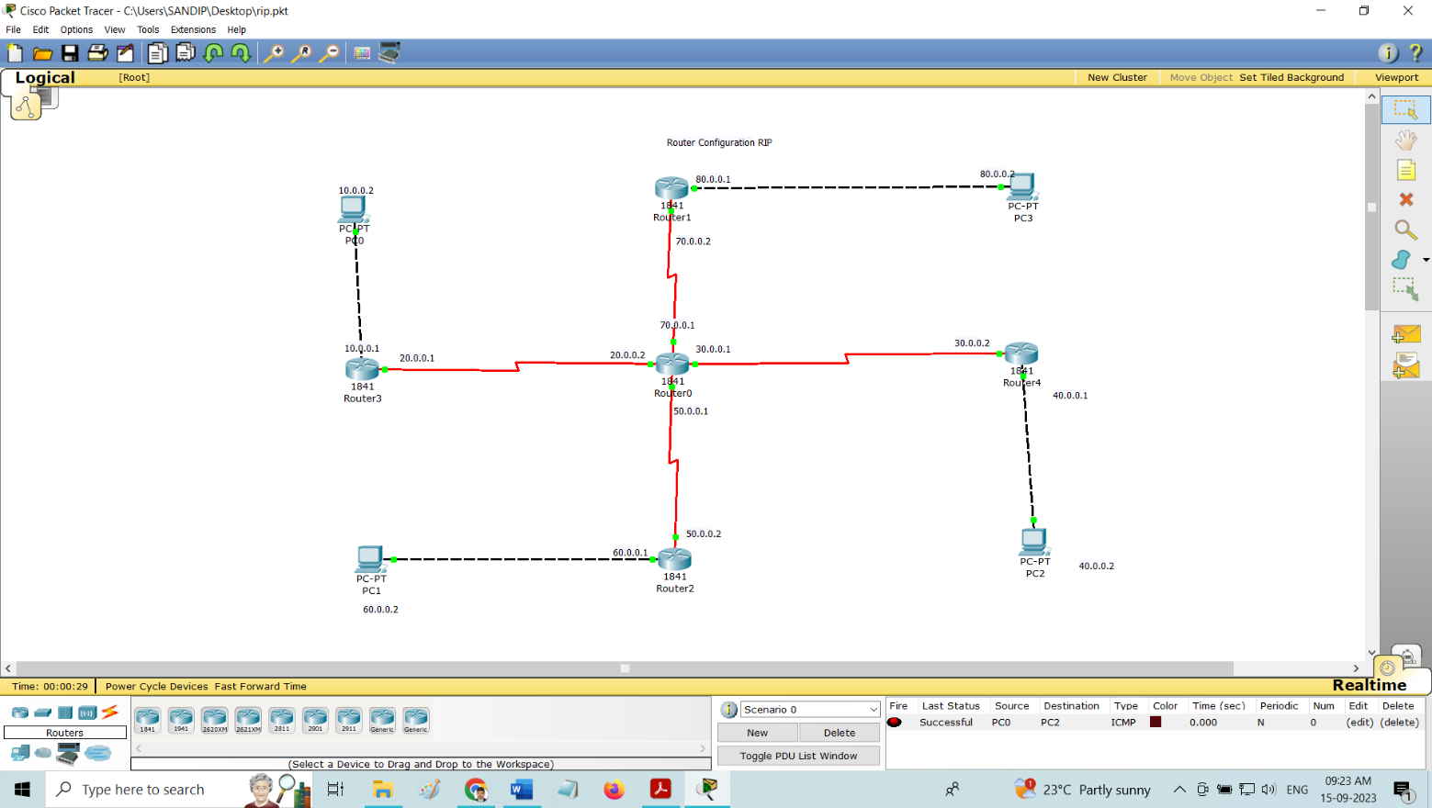

Code
Basic Router Configuration – Static Routing
Router0 Configuration
Router>enable
Router#configure terminal
Enter configuration commands, one per line. End with CNTL/Z.
Router(config)#interface Serial0/1/0
Router(config-if)#ip address 20.0.0.2 255.0.0.0
Router(config-if)#no shutdown
Router(config-if)#
%LINK-5-CHANGED: Interface Serial0/1/0, changed state to up

%LINEPROTO-5-UPDOWN: Line protocol on Interface Serial0/1/0, changed state to up

Router(config-if)#exit
Router(config)#interface Serial0/0/0
Router(config-if)#ip address 30.0.0.1 255.0.0.0
Router(config-if)#no shutdown
Router(config-if)#
%LINK-5-CHANGED: Interface Serial0/0/0, changed state to up

Router(config-if)#exit
Router(config)#interface Serial0/0/1
Router(config-if)#
%LINEPROTO-5-UPDOWN: Line protocol on Interface Serial0/0/0, changed state to up
ip address 50.0.0.1 255.0.0.0
Router(config-if)#no shutdown
Router(config-if)#
%LINK-5-CHANGED: Interface Serial0/0/1, changed state to up

Router(config-if)#exit
Router(config)#interface Serial0/1/1
Router(config-if)#ip address 70.0.0.1 255.0.0.0
Router(config-if)#
%LINEPROTO-5-UPDOWN: Line protocol on Interface Serial0/0/1, changed state to up
no shutdown
Router(config-if)#
%LINK-5-CHANGED: Interface Serial0/1/1, changed state to up

%LINEPROTO-5-UPDOWN: Line protocol on Interface Serial0/1/1, changed state to up
Router(config)#router rip
Router(config)#network 20.0.0.0
Router(config)# network 30.0.0.0
Router(config)# network 50.0.0.0
Router(config)# network 70.0.0.0
Router(config)# do write
Router#show ip route
Codes: C - connected, S - static, I - IGRP, R - RIP, M - mobile, B - BGP
D - EIGRP, EX - EIGRP external, O - OSPF, IA - OSPF inter area
N1 - OSPF NSSA external type 1, N2 - OSPF NSSA external type 2
E1 - OSPF external type 1, E2 - OSPF external type 2, E - EGP
i - IS-IS, L1 - IS-IS level-1, L2 - IS-IS level-2, ia - IS-IS inter area
* - candidate default, U - per-user static route, o - ODR
P - periodic downloaded static route

Gateway of last resort is not set

R 10.0.0.0/8 [120/1] via 20.0.0.1, 00:00:00, Serial0/1/0
C 20.0.0.0/8 is directly connected, Serial0/1/0
C 30.0.0.0/8 is directly connected, Serial0/0/0
R 40.0.0.0/8 [120/1] via 30.0.0.2, 00:00:25, Serial0/0/0
C 50.0.0.0/8 is directly connected, Serial0/0/1
R 60.0.0.0/8 [120/1] via 50.0.0.2, 00:00:21, Serial0/0/1
C 70.0.0.0/8 is directly connected, Serial0/1/1
R 80.0.0.0/8 [120/1] via 70.0.0.2, 00:00:27, Serial0/1/1
Router#

Router1 Configuration
Router>enable
Router#configure terminal
Enter configuration commands, one per line. End with CNTL/Z.
Router(config)#interface FastEthernet0/0
Router(config-if)#ip address 80.0.0.1 255.0.0.0
Router(config-if)#no shutdown

Router(config-if)#
%LINK-5-CHANGED: Interface FastEthernet0/0, changed state to up

%LINEPROTO-5-UPDOWN: Line protocol on Interface FastEthernet0/0, changed state to up

Router(config-if)#exit
Router(config)#interface Serial0/0/0
Router(config-if)#ip address 70.0.0.2 255.0.0.0
Router(config-if)#no shutdown
Router(config)#router rip
Router(config)#network 70.0.0.0
Router(config)# network 80.0.0.0
Router(config)# do write
Router#show ip route
Codes: C - connected, S - static, I - IGRP, R - RIP, M - mobile, B - BGP
D - EIGRP, EX - EIGRP external, O - OSPF, IA - OSPF inter area
N1 - OSPF NSSA external type 1, N2 - OSPF NSSA external type 2
E1 - OSPF external type 1, E2 - OSPF external type 2, E - EGP
i - IS-IS, L1 - IS-IS level-1, L2 - IS-IS level-2, ia - IS-IS inter area
* - candidate default, U - per-user static route, o - ODR
P - periodic downloaded static route
Gateway of last resort is not set
R 10.0.0.0/8 [120/2] via 70.0.0.1, 00:00:11, Serial0/0/0
R 20.0.0.0/8 [120/1] via 70.0.0.1, 00:00:11, Serial0/0/0
R 30.0.0.0/8 [120/1] via 70.0.0.1, 00:00:11, Serial0/0/0
R 40.0.0.0/8 [120/2] via 70.0.0.1, 00:00:11, Serial0/0/0
R 50.0.0.0/8 [120/1] via 70.0.0.1, 00:00:11, Serial0/0/0
R 60.0.0.0/8 [120/2] via 70.0.0.1, 00:00:11, Serial0/0/0
C 70.0.0.0/8 is directly connected, Serial0/0/0
C 80.0.0.0/8 is directly connected, FastEthernet0/0
Router#
Router2 Configuration
Router>enable
Router#configure terminal
Enter configuration commands, one per line. End with CNTL/Z.
Router(config)#interface FastEthernet0/0
Router(config-if)#ip address 60.0.0.1 255.0.0.0
Router(config-if)#no shutdown

Router(config-if)#
%LINK-5-CHANGED: Interface FastEthernet0/0, changed state to up

%LINEPROTO-5-UPDOWN: Line protocol on Interface FastEthernet0/0, changed state to up

Router(config-if)#exit
Router(config)#interface Serial0/0/0
Router(config-if)#no shutdown
Router(config-if)#exit
Router(config)#interface Serial0/0/0
Router(config-if)#ip address 50.0.0.2 255.0.0.0
Router(config-if)#
Router(config)#router rip
Router(config)#network 50.0.0.0
Router(config)# network 60.0.0.0
Router(config)# do write
Router#show ip route
Codes: C - connected, S - static, I - IGRP, R - RIP, M - mobile, B - BGP
D - EIGRP, EX - EIGRP external, O - OSPF, IA - OSPF inter area
N1 - OSPF NSSA external type 1, N2 - OSPF NSSA external type 2
E1 - OSPF external type 1, E2 - OSPF external type 2, E - EGP
i - IS-IS, L1 - IS-IS level-1, L2 - IS-IS level-2, ia - IS-IS inter area
* - candidate default, U - per-user static route, o - ODR
P - periodic downloaded static route
Gateway of last resort is not set
R 10.0.0.0/8 [120/2] via 50.0.0.1, 00:00:17, Serial0/0/0
R 20.0.0.0/8 [120/1] via 50.0.0.1, 00:00:17, Serial0/0/0
R 30.0.0.0/8 [120/1] via 50.0.0.1, 00:00:17, Serial0/0/0
R 40.0.0.0/8 [120/2] via 50.0.0.1, 00:00:17, Serial0/0/0
C 50.0.0.0/8 is directly connected, Serial0/0/0
C 60.0.0.0/8 is directly connected, FastEthernet0/0
R 70.0.0.0/8 [120/1] via 50.0.0.1, 00:00:17, Serial0/0/0
R 80.0.0.0/8 [120/2] via 50.0.0.1, 00:00:17, Serial0/0/0
Router#
Router3 Configuration
Router>enable
Router#configure terminal
Enter configuration commands, one per line. End with CNTL/Z.
Router(config)#interface FastEthernet0/0
Router(config-if)#ip address 10.0.0.1 255.0.0.0
Router(config-if)#no shutdown

Router(config-if)#
%LINK-5-CHANGED: Interface FastEthernet0/0, changed state to up

%LINEPROTO-5-UPDOWN: Line protocol on Interface FastEthernet0/0, changed state to up

Router(config-if)#exit
Router(config)#interface Serial0/0/0
Router(config-if)#ip address 20.0.0.1 255.0.0.0
Router(config-if)#clock rate 64000
Router(config-if)#no shutdown
Router(config)#router rip
Router(config)#network 10.0.0.0
Router(config)# network 20.0.0.0
Router(config)# do write
Router#show ip route
Codes: C - connected, S - static, I - IGRP, R - RIP, M - mobile, B - BGP
D - EIGRP, EX - EIGRP external, O - OSPF, IA - OSPF inter area
N1 - OSPF NSSA external type 1, N2 - OSPF NSSA external type 2
E1 - OSPF external type 1, E2 - OSPF external type 2, E - EGP
i - IS-IS, L1 - IS-IS level-1, L2 - IS-IS level-2, ia - IS-IS inter area
* - candidate default, U - per-user static route, o - ODR
P - periodic downloaded static route

Gateway of last resort is not set

C 10.0.0.0/8 is directly connected, FastEthernet0/0
C 20.0.0.0/8 is directly connected, Serial0/0/0
R 30.0.0.0/8 [120/1] via 20.0.0.2, 00:00:18, Serial0/0/0
R 40.0.0.0/8 [120/2] via 20.0.0.2, 00:00:18, Serial0/0/0
R 50.0.0.0/8 [120/1] via 20.0.0.2, 00:00:18, Serial0/0/0
R 60.0.0.0/8 [120/2] via 20.0.0.2, 00:00:18, Serial0/0/0
R 70.0.0.0/8 [120/1] via 20.0.0.2, 00:00:18, Serial0/0/0
R 80.0.0.0/8 [120/2] via 20.0.0.2, 00:00:18, Serial0/0/0
Router#

Router4 Configuration
Router>enable
Router#configure terminal
Enter configuration commands, one per line. End with CNTL/Z.
Router(config)#interface FastEthernet0/0
Router(config-if)#ip address 40.0.0.1 255.0.0.0
Router(config-if)#no shutdown

Router(config-if)#
%LINK-5-CHANGED: Interface FastEthernet0/0, changed state to up

%LINEPROTO-5-UPDOWN: Line protocol on Interface FastEthernet0/0, changed state to up

Router(config-if)#exit
Router(config)#interface Serial0/0/0
Router(config-if)#ip address 30.0.0.2 255.0.0.0
Router(config-if)#clock rate 64000
This command applies only to DCE interfaces
Router(config-if)#no shutdown
Router(config-if)#do write
Building configuration...
[OK]
Router(config-if)#
Router#config t
Enter configuration commands, one per line. End with CNTL/Z.
Router(config)#router rip
Router(config)#network 30.0.0.0
Router(config)# network 40.0.0.0
Router(config)# do write
Router#show ip route
Codes: C - connected, S - static, I - IGRP, R - RIP, M - mobile, B - BGP
D - EIGRP, EX - EIGRP external, O - OSPF, IA - OSPF inter area
N1 - OSPF NSSA external type 1, N2 - OSPF NSSA external type 2
E1 - OSPF external type 1, E2 - OSPF external type 2, E - EGP
i - IS-IS, L1 - IS-IS level-1, L2 - IS-IS level-2, ia - IS-IS inter area
* - candidate default, U - per-user static route, o - ODR
P - periodic downloaded static route
Gateway of last resort is not set
R 10.0.0.0/8 [120/2] via 30.0.0.1, 00:00:18, Serial0/0/0
R 20.0.0.0/8 [120/1] via 30.0.0.1, 00:00:18, Serial0/0/0
C 30.0.0.0/8 is directly connected, Serial0/0/0
C 40.0.0.0/8 is directly connected, FastEthernet0/0
R 50.0.0.0/8 [120/1] via 30.0.0.1, 00:00:18, Serial0/0/0
R 60.0.0.0/8 [120/2] via 30.0.0.1, 00:00:18, Serial0/0/0
R 70.0.0.0/8 [120/1] via 30.0.0.1, 00:00:18, Serial0/0/0
R 80.0.0.0/8 [120/2] via 30.0.0.1, 00:00:18, Serial0/0/0

Conclusion : <<Write Conclusion in your own words. Write about what you learn from RIP protocol implementation >>

